Alstroemeria, Peruvian Lily
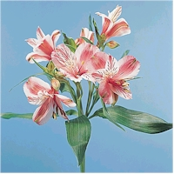

Common Names: Alstroemeria, Alstro, Peruvian lily, Inca lily, lily of the Incas
Botanical Name: Alstroemeria, (al-str-MEAR-ee-ah)
Availability: Year-round
Vase Life: Long lasting, Each individual flower lasts about 1 week and each stem will have blooms for up to 2 weeks.
Storage Temperature: 36-38F
Ethylene Sensitive: Yes, very sensitive. Ethylene damage includes flower fall and transparent petals.
Description: Clusters of delicate, trumpet shaped flowers on the end of short flower stalks that spray off of a single stem.
Colors: Purple, pink, dark pink, white, yellow, red, orange, and rust. Most colors are freckled or streaked with contrasting colors.
Botanical Facts: The Swedish Consul in Spain, Klas Alstroemer had seeds of this species brought to Europe in 1754. Carl Linnaeus, a friend of Alstroemer, subsequently named the species after him. Alstroemeria is native to the moutains of Peru and Bolivia.
Design Notes: With multiple blooms on the end of each stem, Alstroemeria is a great flower to add more value to any arrangement. The colors of Alstroemeria mix beautifully with Asiatic lilies.
Purchasing Hints: Purchanse when clusters have one or two flowers open and other buds showing color. Stems and leaves should be deep green.
Conditioning: Remove all of the foliage below the water line of the vase and most foliage below the blossoms of the flower. Note that their must be some leaves present for water uptake. Cut under water with a sharp knife. Be sure to remove the whitish portion of the lower stem if it is present. Hydrate in warm water for two hours before storage or usage. Use commercial floral food / preservative.
Additional Notes: Alstroemeria can cause an allergic dermatitis in some individuals. While this is not common and usually occurs after extended exposure to a large volume of product, care should be exercised when handling Alstroemeria. Anyone handling Alstroemeria should wash their hands with soap and water after exposure. Individuals who prove to be sensitive to Alstroemeria should handle the product with gloves. Always seek medical attention if an allergic reaction is severe. Leaf yellowing can be a problem with certain cultivars of Alstroemeria and is aggravated by floral preservative. Remove yellowing leaves and avoid cultivars with leaves that yellow in future purchases.

Gypsophila, Baby's Breath
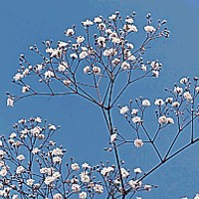
Common Names: Baby's Breath, Gypsophila, Gyp
Botanical Name: Gypsophila, (jip-SOF-i-la)
Availability: Year Round
Vase Life: 5 to 7 days.
Storage Temperature: 36 - 38 F
Ethylene Sensitive: Yes, very sensitive
Description: Bunches of complex branches filled with dozens of tiny florets.
Colors: White. Pink is available, but uncommon
Botanical Facts: Gypsophila comes from the Greek for "gypsum-loving" in reference to the plants favoring of high calcium soils.
Design Notes: Baby's Breath is a very popular (and sometimes overused) filler flower. Small clusters of blossoms also work well in wedding and corsage design.
Purchasing Hints: Purchase bunches that are filled with open florets and closed buds. One half of the florets should be open. Avoid bunches with blossoms that are showing any signs of browning. There is a wonderful new species of Baby's Breath on the market called "Million Stars" (elagans paniculata) which is leading a renewed popularity of Baby's Breath.
Conditioning: Remove all foliage that will be below the water line. Cut under water with a sharp knife. Hydrate in a solution of warm water and commercial floral preservative / floral food for two hours before storage or usage. To speed the opening of blossoms. Pour one gallon of boiling water into a one gallon storage bucket. To this add two tablespoons of bleach. Then place the stem ends of the Baby's Breath into the hot bleach-water solution. you will be able to actually watch (and hear) the florets pop open like miniature popcorn.
Additional Notes: Baby's Breath can be a very hardy, long lasting filler flower. However, it is very sensitive to ethylene, water stress and botrytis. Make sure that storage buckets are clean and always use a commercial floral preservative / floral food containing a fungicide. Baby's Breath needs to be stored in high relative humidity to avoid stem desiccation. Do not "mist" Baby's Breath as this may cause blossom browning. Baby's Breath does dry easily and well. However, drying Baby's Breath generates very high levels of ethylene gas. Dry Baby's Breath in a well venelated area, away from other flowers.

Carnation, Dianthus caryophyllus
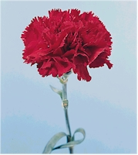

Common Names: Carnation, Pinks, Chinese Pink
Botanical Name: Dianthus (die-ANTH-us)
Availability: Year-round
Vase Life: 7 to 14 days.
Storage Temperature: 36 - 38 F
Ethylene Sensitive: Yes
Description: A single flower, delicate multi-petaled, double blossom at the end of a long stem.
Colors: Wide range of colors, not limited to: Pink, white, red, purple, yellow, and orange. Plus bi-colors and frosted varieties.
Botanical Facts: The name is from the Greek words (DI) Zeus and (ANTHOS) Flower
Design Notes: The wide range of colors and the versatility of the carnation makes it a popular flower in floral design.
Purchasing Hints: Purchase flowers with tight buds. Avoid flowers with broken stems, shattered blooms, split calyx, or blossoms with the pistil exposed above the blossom.
Conditioning: Remove all foliage that will be below the water line. Cut under water with a sharp knife. Hydrate in a solution of warm water and commercial floral preservative / floral food for two hours before storage or usage.
Additional Notes: The popularity of the carnation waxes and wanes. In the French Grand Era, (Louis XIV), the carnation was the favored flower of the royal court. In America today, the carnation is seen as an old fashioned and overused flower. However, it is coming back into favor with both interior and floral designers. Their strong shape can add a touch of modernity to interiors. We find them today not in the pale pastels, but in piquant pink, fiery red and various hectic orange hues.
And the way to arrange them has changed too. Gone are the spiky triangles with the lonely carnation heads stranded in mid air; and so have the single blobs of color strewn around bouquets. You can bind them together in bunches with ribbon and lean against vase sides at crazy angles; crowd them together in large numbers in tall glass vases; float in wide bowls or as a collection of small bouquets fringed by attractive round leaves. Carnations can easily tempt you into having a go! The new methods of arranging are based on simplicity and exuberance. Carnations make a vivid contribution to the metamorphosis going on in the style of our homes.

Chrysanthemum
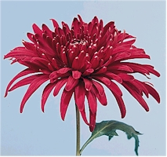
Common Names: Chrysanthemum, (kris-ANTH-e-mum), Multi-branching, multiple head varieties know as Pompon, Daisy, Button and Spray Chrysanthemum. Single head varieties known as Standard Chrysanthemum, Mum, Florist's Mum, Cushion Mum, Spoon mum, Fuji Mums, Spider Mums, and Football Mums.
Botanical Name: Dendranthema X Grandiflorum (den-drahn-THEE-ma x gran-di-FLOR-um)
Formerly known as Chrysanthemum morifolium
Availability: Year-round
Vase Life: 7 to 14 days
Storage Temperature: 36 - 38 F. Note: Storage temperatures can range from 32 - 55 F, depending upon cultivar.
Ethylene Sensitive: No
Description: A wide variety of shapes and sizes.
Colors: White, yellow, pink, red, lavender, gold, bronze.
Botanical Facts: The name is Greek for "Golden Flower".
Design Notes: Multiple head varieties make excellent filler flowers. Single head varieties provide mass and emphisis.
Purchasing Hints: Multiple head varieties; Purchase stems with three quarters of the flowers in bloom. Single head varieties; Purchase tight blossoms. In both, look for dark green, turgid foliage. Avoid dry, brittle stems and blossoms that are shattering.
Conditioning: Remove all foliage that will be below the water line. Cut under water with a sharp knife. Hydrate in a solution of warm water and commercial floral preservative / floral food for two hours before storage or usage. Make sure that the water and commercial floral preservative / floral food is of proper concentration. A high concentration of commercial floral preservative / floral food can cause leaf yellowing. The bottom portion of some mum stems can be woody, make sure that you cut the stems abolve this woody tissue in order to faciliate water uptake.
Additional Notes: Handle the flowers carefully to avoid shattering of the blossoms. To prevent blossom shattering in some cultivars which are highly vulnerable to shattering, (Fuji & Spider Mums) you can spray a commercial product "Mum Tight" on the back of the blossoms, or you can melt candle wax on the back side of the flowers.

Gerbera, Transvaal Daisy
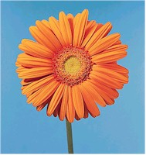
Common Names: Gerbera, Gerbera Daisy, Transvaal Daisy, African Daisy, Barberton Daisy, Veldt Daisy
Botanical Name: Gerbera (GER-be-rah)
Availability: Year-round
Vase Life: 7 to 10 days
Storage Temperature: 36 - 38 F
Ethylene Sensitive: No
Description: Daisy-shaped flowers 2 to 5 inches in diameter, on long, hollow, leafless stems 12 to 18 inches long. Single, double and multi-petaled varieties are available.
Colors: Oranges, reds, pinks, whites, yellows and bi-colors, some with contrasting centers.
Botanical Facts: Gerbera was named after Traug Gerber, (1700s) a German naturalist.
Design Notes: A wonderful and colorful flower to design with, Gerbera blossoms can be a focal point or add mass to a floral design. Gerberas are phototropic and flower heads may turn to face a strong light.
Purchasing Hints: Purchase blossoms with at least one row of disk flowers (tubular flowers in the center of the head) are showing pollen. Look for unbruised, fully round heads with unblemished petals on long, straight, upright stems.
Conditioning: Cut stems under water with a sharp knife. Hydrate in a solution of warm water and commercial floral preservative / floral food for two hours before storage or usage. Gerberas should be suspended by their heads during the hydration process. This can be done by positioning a wire grid over a bucket of solution, then slipping the stems through the grid. The flower heads should rest on the grid and the stems suspend in the water without touching the bottom. This will result in straight stems, and eliminate the need for wiring.
Additional Notes: Gerberas are sensitive to fluoride. Fluoridated water can cause petal tip burn. If flowers are properly conditioned, bent necks should not occur. If a bent neck does occur it is probably the result of clogged stems due to dirty vase water. Gerberas are very heavy water drinkers and will last longer in vase water than in floral foam. There are currently over 300 different varieties of Gerbera being grown for the floristry market.

Gladiolus
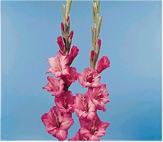
Common Names: Gladiolus, Sword Lily, Glad, Corn Flag
Botanical Name: Gladiolus (gla-dee-OH-lus)
Availability: Year-round. Primary season - April through December.
Vase Life: 7 to 14 days.
Storage Temperature: 36 - 38 F
Ethylene Sensitive: Yes
Description: A thick stem with multiple blossoms located on one side of the stem. Blossoms may be plain, fringed or ruffled and forms may vary from trumpet shaped to rosebud-like to tulip shaped.
Colors: White, pink, red, orange, yellow, purple, green and bi-colors. A wide range of bright and pastel shades are available.
Botanical Facts: Gladiolus is Latin for small sword. A reference to the sword shaped leaves or the shape of a Gladiolus stem with unopened blossoms.
Design Notes: Gladiolus are excellent line flowers and are frequently used in sympathy work. The individual blossoms are used in corsages and can be glued together to make composite flowers.
Purchasing Hints: Purchase long unbroken stems with bright green foliage. Blossoms on the lower quarter of the stem should be starting to open with three quarters of the remaining buds showing color.
Conditioning: Remove all foliage that will be below the water line. Cut under water with a sharp knife. Hydrate in a solution of warm water and commercial floral preservative / floral food for two hours before storage or usage.
Additional Notes: Gladiolus are highly geotropic and need to be stored upright until used. The tips will curve away from the pull of gravity. Fluoridated water can cause petal edge and leaf tip burn. Monitor water supply carefully as Gladiolus are very heavy drinkers. Snapping off the top inch of the stem will help promote water uptake.
The shape of the gladiolus betrays the source of the flower's name. Gladiolus comes from the Latin word for a small sword. And fiery swords is indeed what these flowers resemble most, with their bright colors and their erect buds.

Solidago, Goldenrod
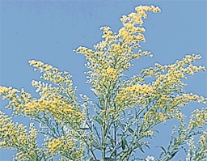
Common Names: Solidago, Goldenrod
Botanical Name: Solidago, (so-li-DAY-go)
Availability: March through November
Vase Life: 7 to 10 days.
Storage Temperature: 36 - 38 F
Ethylene Sensitive: Yes
Description: Dense clusters of tiny flowers forming feathery plumes.
Colors: Yellow
Botanical Facts: The name is from the Latin word Solido, meaning to make whole or strengthen. This is a reference to the plants medicinal properties.
Design Notes: Excellent filler flower. Can be used as a mass flower.
Purchasing Hints: Purchase stems with florets just starting to open.
Conditioning: Remove all foliage that will be below the water line. Cut under water with a sharp knife. Hydrate in a solution of warm water and commercial floral preservative / floral food for two hours before storage or usage.
Additional Notes: Be aware that Solidago causes an allergic reaction in many people.

Hydrangea
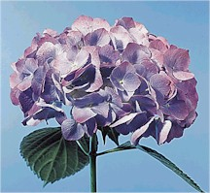

Common Names: Hydrangea
Botanical Name: Hydrangea (hi-DRAN-jee-ah)
Availability: May through November, peak supply July through September.
Vase Life: 5 to 10 days.
Storage Temperature: 36 - 38 F
Ethylene Sensitive: Yes
Description: Large rounded clusters of florets with star-like petals.
Colors: White, pinks and blues.
Botanical Facts: The name is from the Greek words hydro (water) and aggos (jar) referring to the fruits which are shaped like cups.
Design Notes: A wonderful mass flower with beautiful coloration and textural interest in large arrangements. Hydrangeas are very popular in wedding design.
Purchasing Hints: Purchase brightly colored, full flower heads with well hydrated leaves.
Conditioning: Remove all foliage that will be below the water line. Cut under water with a sharp knife. Hydrate in a solution of warm water and commercial floral preservative / floral food for two hours before storage or usage.
Additional Notes: Hydrangeas are very wilt sensitive and can be very tricky to work with. If after general procedures for hydration the blossoms still wilt, recut the stem ends then place them in a clean vase with four inches of boiling water. Allow the flowers to hydrate for several hours before storage or usage.

Hypericum, Coffee Bean
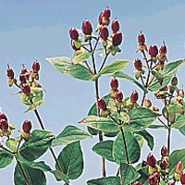

Common Names: Hypericum, Coffee Bean, St John's Wort
Botanical Name: Hypericum, (hi-PEAR-i-kum)
Availability: June through December
Vase Life: 7 to 14 days.
Storage Temperature: 36 - 38 F
Description: Clusters of shiny, brightly colored berries.
Colors: Berries are most commonly reddish brown. Can be found in green and red.
Botanical Facts: At one time Hypericum was hung over pictures to ward off evil spirits. Hence the name from the Greek words hyper (above) and eikon (a picture).
Design Notes: Hypericum is a wonderful filler in bouquets. The berries add interest and texture.
Purchasing Hints: Purchase stems with turgid foliage and firm shiny berries.
Conditioning: Remove all foliage that will be below the water line. Cut under water with a sharp knife. Hydrate in a solution of warm water and commercial floral preservative / floral food for two hours before storage or usage.

Consolida, Larkspur
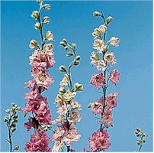
Common Names: Consolida, Larkspur
Botanical Name: Consolida, (kon-so-li-da)
Availability: June through September
Vase Life: 4 to 12 days.
Storage Temperature: 36 - 38 F
Ethylene Sensitive: Yes
Description: Longer slender stems with blossoms clustered along the upper portion of the stem.
Colors: Blue, Lavender, Pink, White and shades.
Botanical Facts: The name is from the Latin consolida (to make whole). This is a reference to the medicinal qualities of Consolida
Design Notes: Can be used as a mass and line flower.
Purchasing Hints: Purchase when at least two blossoms per stem are fully opened. Avoid product that is showing signs of flower fall.
Conditioning: Remove all foliage that will be below the water line. Cut under water with a sharp knife. Hydrate in a solution of warm water and commercial floral preservative / floral food for two hours before storage or usage.
Additional Notes: Larkspur foliage is sensitive to mildew. Use commercial floral preservative / floral food and good sanitation practices.

Lilium, Lily
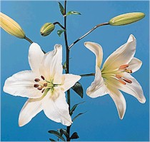
Common Names: There are three primary groups of Lilium; Oriental Lilies, Asiatic Lilies, and Easter Lilies
Botanical Name: Lilium (LIL-ee-um)
Availability: Year-round, peak supplies by season
Vase Life: 7 to 14 days per stem, 4 to 7 days per bloom.
Storage Temperature: 36 - 38 F
Ethylene Sensitive: Yes
Description: Flowers appear on short branches at the end of the stem. Oriental; Cup-shaped flowers with elongated petals, 4 to 8 inches across, 3 to 6 flowers on stems 24 to 36 inches long. Asiatic; Cup-shaped flowers , 4 to 6 inches across, clusters of 5 to 8 flowers on stems 24 to 36 inches long. Easter; Fragrant, long trumpet-shaped blossoms growing sideways from the single vertical stem, 1 to 6 blossoms per stem.
Colors: White, cream, reds, pinks, yellows, and bi-colors, some with characteristic markings.
Botanical Facts: The name is Latin for the flower Lily.
Design Notes: These beautiful blossoms work well in mixed seasonal arrangements and more contemporary styled designs. Lilies are excellent focal flowers.
Purchasing Hints: Purchase when one or two of the buds are just open and the closed buds showing color and nearing maturity. Avoid stems with yellowing foliage or transparent petals.
Conditioning: Remove all foliage that will be below the water line. Cut under water with a sharp knife. Hydrate in a solution of warm water and commercial floral preservative / floral food for 12 hours before storage or usage. Allow space in storage buckets for blossoms to open fully. Remove pollen bearing anthers as the blossoms open.
Additional Notes: Lily pollen can perminately stain clothing. Use gloves when removing anthers. If pollen should get on flower petals, gently brush it off with a chenille stem. If pollen should get on clothing, immediately lift it of by gently touching the pollen with sticky tape.

Paeonia, Peony
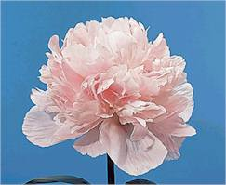
Common Names: Peony
Botanical Name: Paeonia, (pee-OH-ne-ah)
Availability: March through July.
Vase Life: 5 to 7 days.
Storage Temperature: 36 - 38 F
Ethylene Sensitive: Yes
Description: Large, fragrant, terminal blossoms 3 to 8 inches across on stems 12 to 24 inches long.
Colors: Red, pink, rose, burgundy and white.
Botanical Facts: The name is from the Greek name paionia. A reference to Paion, then physician to the gods in Greek mythology.
Design Notes: These large beautiful blossoms work well alone in a bouquet or in mixed arrangements. Peony blossoms make a excellent focal point. Be sure to allow room in an arrangement for the blossoms to open fully. Peonies are wilt sensitive and last far better in vase of water, compared to designing them in floral foam.
Purchasing Hints: Purchase stems with fairly tight buds, with the calyxes just beginning to open. The buds should be showing well developed color. Once the flowers open the vase life is short.
Conditioning: Remove all foliage that will be below the water line. Cut under water with a sharp knife. Hydrate in a solution of warm water and commercial floral preservative / floral food for two hours before storage or usage. Keep peonies in a cool dark location to retard opening.
Additional Notes: Peonies create an atmosphere of understated opulence. They inspire images of grand porcelain bowls of peonies gracing the boudoirs of distinguished ladies in stately homes, mansions and small castles. Peonies have long been cultivated with care in walled gardens and epitomize that full-blown English garden look. Japan too loves peonies. Their earliest peony blooms are individually protected against snow by small thatched shelters. Some geishas used to wear special peony colors. The Chinese, too, idolized this flower. We find peony motifs, particularly bright red ones, on Chinese silks and in their exuberant wood-carvings. The common thread is that the flower always denotes luxury and indulgence.

Rosa, Rose
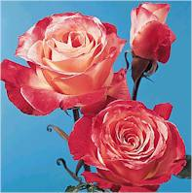
Common Names: Rose
Botanical Name: Rosa, (RO-za)
Availability: Year-round
Vase Life: 3 to 14 days.
Storage Temperature: 36 - 38 F
Ethylene Sensitive: Yes
Description: Floristry roses are grouped into three basic categories; Hybrid Tea Rose, the most common rose, has a single blossom, 1 & 1/2 to 3 inches long, opening 3 inches to 5 inches across, on stems 12 to 40 inches long. Larger blossoms 4 to 5 inches across are known as "South American head size", Intermediate blossoms 3 inches to 4 inches are know as "European head size". Spray Rose, buds are 1/2 to 1 inch long, opening 2 to 3 inches across, with multiple flowers branching from the stem. Sweetheart Rose, single blossom, 1/2 to 1 inch long opening to 2 to 3 inches across on a stem 6 to 15 inches long.
Colors: Very wide range of colors.
Botanical Facts: The name is from the Latin word rana (frog) referring to the fact that many wild roses grow in wet areas. (A Frog???... now, isn't that romantic?)
Design Notes: Roses are used in a wide range of floral designs, bouquets, and arrangements, as well as corsage and wedding flowers.
Purchasing Hints: Purchase tight, semi-firm heads just beginning to open. The stems should be straight, strong and unscarred. Leaves should be dark green and turgid..
Conditioning: Remove all foliage that will be below the water line. Carefully remove thorns using a "Rose Glove". Cut under water with a sharp knife. Hydrate in a solution of warm water and commercial floral preservative / floral food for two hours before storage or usage. If roses are conditioned properly, they should have a long vase life, open completely, and never have a "bent neck". If your roses are wilting, check out the "emergency care" in our care & handling section.
Additional Notes: Roses are perhaps the best-known flowers in the world. They are cultivated from South America to Africa, from Eastern Europe to the Far East. In many countries roses are strongly connected to special events, ceremonies, and symbolic events. In Europe and America, roses are synonymous with Valentine's Day, a floral symbol of love and passion.

Limonium, Statice
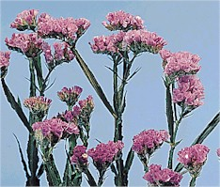
Common Names: Statice, Misty, Seafoam Statice, German Statice, Limonium, Caspia.
Botanical Name: Limonium, (lee-MO-nee-um)
Availability: Year-round.
Vase Life: 7 to 14 days.
Storage Temperature: 36 - 38 F
Ethylene Sensitive: No
Description: A large family of diverse shapes and sizes. Blossoms are tiny white or yellow flowers surrounded by papery bracts of lavender, white, pink, yellow and purple. Often the true flower is absent and the bracts make up the blossom.
Colors: Lavender, white, pink, yellow and purple.
Botanical Facts: The name is from the Greek word leimon, meaning meadow. A reference to the natural habitat of Limonium.
Design Notes: An excellent and colorful filler flower. Used often in mixed bouquets. Misty and caspia add wonderful motion to arrangements.
Purchasing Hints: Purchase stems with open bracts in full color and sturdy stems. Avoid any stems with any signs of mildew or brown spots.
Conditioning: Remove all foliage that will be below the water line. Cut under water with a sharp knife. Hydrate in a solution of warm water and commercial floral preservative / floral food for two hours before storage or usage.
Additional Notes: Limonium is subject to mildew. Allow room in storage buckets for air to circulate. Change water solution frequently. The variety "Caspia" has a natural musky odor which some people compare to "cat-pee" and should not be used in arrangements planned for confined areas with limited air circulation.
Statice dries well and is a very common dried material.

Helianthus, Sunflower
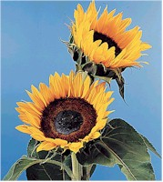
Common Names: Sunflower,
Botanical Name: Helianthus (hee-li-ANTH-us)
Availability: April through November
Vase Life: 7 to 10 days.
Storage Temperature: 36 - 38 F
Ethylene Sensitive: No
Description: Very lage daisy-like composite blossoms, with petals (ray florets) surrounding a contrasting center (disc florets).
Colors: Yellows, oranges, reds, browns and creams. Contrasting center colors are available. Dyed tints are also available.
Botanical Facts: The name is from the Greek words, helios (sun) and anthos (flower)
Design Notes: Sunflowers are bold focal flowers. The heavy heads and large stems require the use of reinforced floral foam in floral design. The development of cultivars with smaller heads has made the sunflower more popular in floral design.
Purchasing Hints: Purchase unbruised buds that are just opening. Avoid flowers with yellow or wilted leaves.
Conditioning: Remove all foliage that will be below the water line. Cut under water with a sharp knife. Hydrate in a solution of warm water and commercial floral preservative / floral food for two hours before storage or usage.
Sunflowers dry well. Prop several stems in a vase, or hang them in a well-ventilated, warm area and allow them to air dry.
Additional Notes: Although most Americans view sunflowers as a flower from France, the sunflower is a native of Mexico and Peru, introduced into this country in the sixteenth century.

Tulipa, Tulip
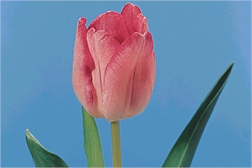
Common Names: Tulip
Botanical Name: Tulipa, (TEW-li-pa)
Availability: November through May, limited availability year-round.
Vase Life: 3 to 7 days.
Storage Temperature: 36 - 38 F
Ethylene Sensitive: No
Description: Deep cup shaped blossoms, 2 to 4 inches high born on solid stems 12 to 24 inches high. Tulip blossoms are grouped into four categories; single-rounded, double-rounded, parrot (fringed), and lily flowered (pointed petals).
Colors: Red, pink, white, yellow, orange, purple and bi-colors.
Botanical Facts: The name is from the Turkish word tulband, for turban.
Design Notes: These colorful blossoms are commonly displayed as a mono-botanical in a vase arrangement. They are frequently used in mixed spring arrangements, hand-tie bouquets, landscape, vegetative, and botanical design styles.
Purchasing Hints: Purchase tight heads deep in turgid foliage and just showing color. The stems should be straight and strong.
Conditioning: Cut stems under water with a sharp knife removing all of the white portion of the stem. Hydrate in a solution of warm water and commercial floral preservative / floral food for two hours before storage or usage. To keep stems straight, wrap a bundle of stems in paper while the flowers are conditioning.
Additional Notes: Tulips are very phototropic and will curve rapidly toward the light. Designers must allow for this in creating a floral design as well as the fact that cut tulips continue to grow in length approximately one inch per day.

Birds of Paradise
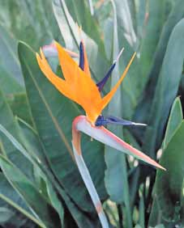

Birds of Paradise, also known as Crane flowers is one of the most beautiful Exotic Flowers. Birds of Paradise are native to South Africa. Birds of Paradise bloom from September through May.
The flowers of the Birds of Paradise resemble a brightly colored bird in flight and so the name Birds of Paradise.

Kingdom- Plantae
Division-Magnoliophyta
Class-Liliopsida
Order-Zingiberales
Family-Strelitziaceae
Genus-Strelitzia
The unusually beautiful shape and brilliant colors of Birds of Paradise have made these flowers not just a designer's favorite, but also a popular symbol of paradise.

Birds of Paradise Plant Care
•The Bird of Paradise does require a good amount of sunlight.
•Follow a regular watering schedule during the first growing season to establish a deep, extensive root system for the Birds of Paradise.
•Watering can be reduced after establishment.
•Feed Birds of Paradise plants with a general purpose fertilizer before new growth begins in spring.
•Floral preservative for Birds of Paradise is recommended and is available commercially.

Leather Leaf
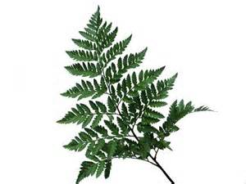

Common Name: Leatherleaf, Leatherleaf Fern
Botanical Name: Rumohra adiantiformis (ru-MOW-ra ad-ee-an-ti-FOR-mis)
Decorative Life: 7-21 days.
Post Harvest Care:
•Avoid fresh flower foods, as the fronds (leaves) will often turn yellow. Thus, recut stems under water and place into a hydration solution or water plus regular household bleach at 20 drops (1/4 teaspoon) per quart. It is reported that some leaf sprays and dips like Hydroseal, Pixie Sparkle or Saf-T-Foliage can be used to extend life. Indeed, better results can be obtained by using anti-tranapirants to reduce frond wilting by reducing water loss than to use hydration solutions to improve water uptake.
•Frond curl or wilt is a physiological disorder characterized by partial or complete folding of the pinna (leaflets) along the midvein and/or complete frond wilting. It is a major problem for the leatherleaf industry, especially in mid to late summer. Research suggests that it is better to reduce water loss than to increase water uptake as a major way to prevent or reduce frond wilt or curl disorder.
Harvest Instructions: Plants grown at 68F day, 60 night temperatures lasted 36% longer compared to those grown at 86F day, 77F night temperatures. Fronds harvested from tissue cultured propagated cultivars generally last longer than those not from tissue culture. On average, larger size fronds tend to not last as long as smaller size ones harvested from the same cultivars. Most leatherleaf is dipped after harvest in various mixtures of water, mineral oil and surfactant to both clean and hopefully extend subsequent vaselife. Commercial products sold for this purpose include Hydroseal, Pixie Sparkle or Saf-T-Foliage. When vaselife is naturally two weeks or longer for non-treated fronds, these treatments add little value. However, vaselife can be significantly extend up to nearly 300% when dipped in these solutions at times of the year when non-treated fronds last less than two weeks. Fronds produced under high night temperature (77F) did not last as long as ones produced at 60F. High percentages of urea containing fertiliers should not be used with this species as decreased yield and quality are likely.
Availability: Year-round.
Storage Specifics: Can be stored at 34-45F (3 days or less), 40-42 (more than 3 days). Best to provide high relative humidity for both wet and dry storage.

Extra Flowers!!

Liatris
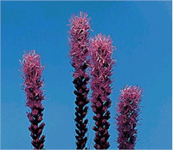
Common Names: Liatris, gay feather, purple poker, blazing star.
Botanical Name: Liatris, (lei-AH-tris)
Availability: Year-round
Vase Life: 7 to 10 days
Storage Temperature: 36 - 38 F
Ethylene Sensitive: No
Description: Long straight stems topped with a single straight spike clustered with tiny florets. Liatris is an unusual blossom in that the florets open at the top of the spike first, then open downward.
Colors: Lavender and white.
Botanical Facts: Liatris in native to North America.
Design Notes: Excellent for creating a strong line in arrangements. Very popular in contemporary floral design.
Purchasing Hints: Purchase long straight stems with no more than three quarters of the florets open at the top.
Conditioning: Remove all foliage that will be below the water line. Cut under water with a sharp knife. Hydrate in a solution of warm water and commercial floral preservative / floral food for two hours before storage or usage.
Additional Notes: Liatris does dry well. The dried product should be sprayed with a sealant to prevent shattering.

Antirrhinum, Snapdragon
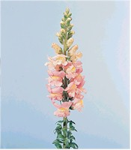
Common Names: Antirrhinum, snapdragon,
Botanical Name: (an-tee-RYE-num)
Availability: Year round with peak supplies from June through October.
Vase Life: 5 to 6 days.
Storage Temperature: 36-38 F
Ethylene Sensitive: Yes, very sensitive.
Description: A spiked, terminal raceme with multiple florets. The florets are shaped like little dragon heads, with upper and lower lips which will open when you gently squeeze the sides of the blossom.
Colors: Purple, pink, blue, white, yellow and red.
Botanical Facts: From the Greek words anti (like) and rhis (snout) referring to the appearance of the individual florets.
Design Notes: Snapdragons are very geotropic. Realize that their tips will turn up if they are angled sharply in a floral design. They make outstanding mass flowers if cut short.
Purchasing Hints: Purchase straight stems with florets open on the lower one third to two thirds of the spike. Buds at the top of the spike should show some color.
Conditioning: Remove all foliage that will be below the water line. Cut under water with a sharp knife. Hydrate in a solution of warm water and commercial floral preservative / floral food for two hours before storage or usage.
Additional Notes: Snapdragons are heavy drinkers. Renew water solution frequently and beware of bacterial bloom in the vase water. Snapdragons are very geotropic and will vertically bend away from gravity. Always store upright.

Matthiola, Stock
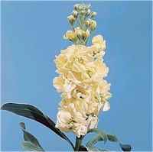

Common Names: Stock
Botanical Name: Matthiola (ma-THEE-oh-lah)
Availability: Year-round, January through October is the peak season.
Vase Life: 5 to 7 days.
Storage Temperature: 36 - 38 F
Ethylene Sensitive: Yes
Description: Fragrant, tightly clustered one inch florets on a spike topping a single stem.
Colors: White, red, pink, cream, purple, lilac, yellow, peach.
Botanical Facts: This flower was named after the Italian botanist Pierandrea Mattioli, 1500 - 1577.
Design Notes: These beautiful blossoms add line and mass to mixed arrangements.
Purchasing Hints: Purchase when one half to two thirds of the florets are open. Stems should be straight and sturdy. Avoid any stems with the lower florets decaying, or any signs of mildew.
Conditioning: Remove all foliage that will be below the water line. Cut under water with a sharp knife. Hydrate in a solution of warm water and commercial floral preservative / floral food for two hours before storage or usage.
Additional Notes: Stock is susceptible to mildew. Change the water solution frequently.

Chamelaucium, Wax Flower
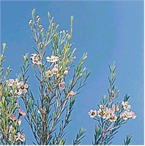
Common Names: Chamelaucium, Wax Flower
Botanical Name: Chamelaucium, (cham-ee-LAW-si-um)
Availability: September through May
Vase Life: 7 to 10 days.
Storage Temperature: 36 - 38 F
Ethylene Sensitive: Yes
Description: Star shaped blossoms of five petals. The foliage is needlelike, on woody branching stems.
Colors: White, pink, lavender and bi-color.
Botanical Facts: Related to eucalyptus. Foliage releases a delightful lemon - citrus fragrance when crushed.
Design Notes: Wonderful filler flower. Flexible branches give motion to larger vase arrangements.
Purchasing Hints: Purchase when one quarter of the blossoms are open. Branches should be very pliable.
Conditioning: Remove all foliage that will be below the water line. Cut under water with a sharp knife. Hydrate in a solution of warm water and commercial floral preservative / floral food for two hours before storage or usage.

